Installation Guide

Arduino IDE Installation:

1. Open the Arduino 1.8.6 executable file and accept the License Agreement.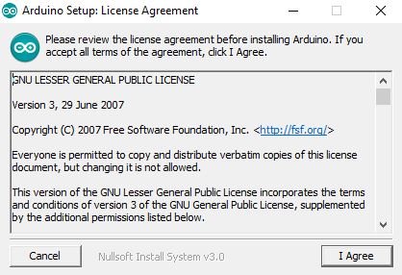
2. Check all the boxes and click next.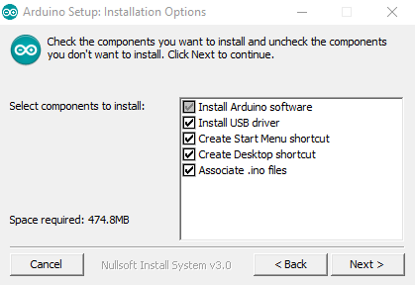
3. Select the destination location for installation or leave the default location as such and click install.

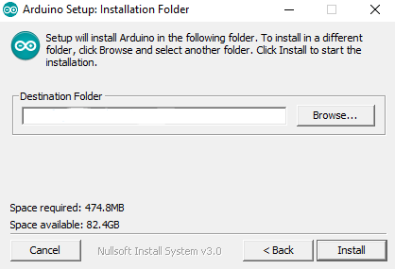

1. Click finish and you’re all set to use the Arduino IDE.

Python Installation:

NOTE: Ensure that you are using Python 3.6 version as it is mandatory for the workshop.

You can install it parallel to Python 2.7 or freshly install Python 3.6.

Fresh installation

1. Open the executable file and Check the Add Python 3.6 to PATH. Then click the Install Now button. It will show the installation progress.

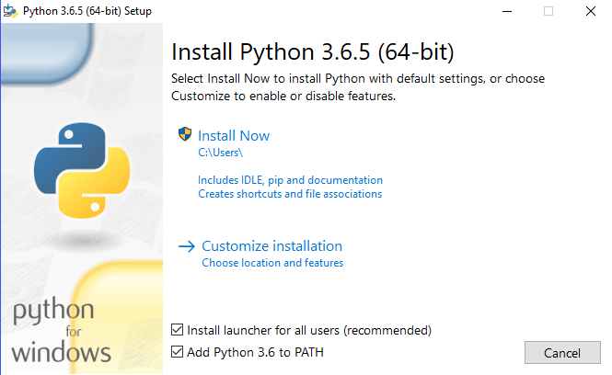

1. When the installation progress is completed, you will see the Disable path length limit. Now you must be thinking what is it and what will happen if I will disable it. The answer is clear, it will remove the limitations on MAX_PATH variable. It will allow to use long path names for the Python. We recommend you to **not** disable this option as it will remove any path related issues while working in Windows. Therefore click on the **close button** to finish the installation.

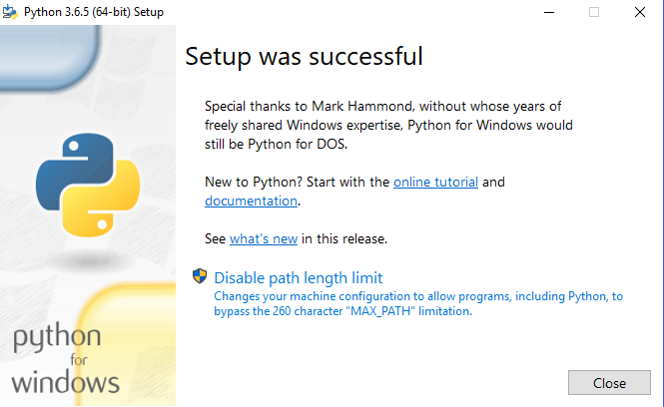

1. Open command prompt from the search bar on the taskbar.
2. Type the following command and press enter to upgrade pip. Pip comes along with Python 3.6 pre-installed, so you don’t have to install it separately.

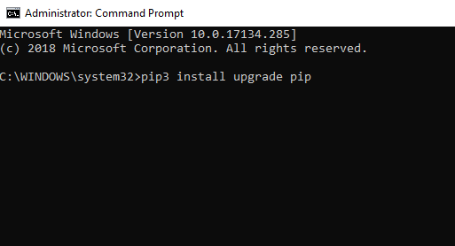

1. To install opencv, run the following command in the command prompt.

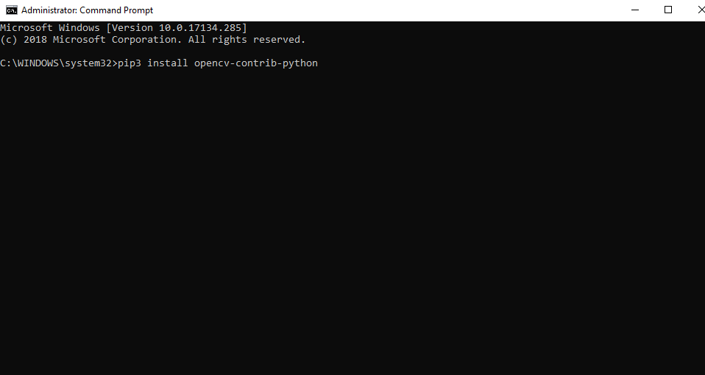

1. Run the following command to install pyserial

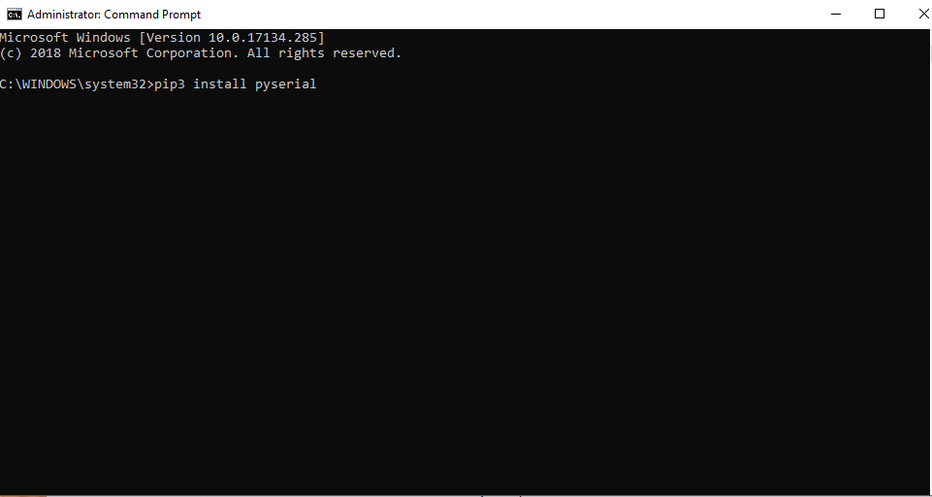

Install parallel to Python 2.7

NOTE: All the above steps are the same for parallel installation as well. However, to be able to use both the versions of python through PATH or command prompt, open the file location of each version and create a copy of the .exe file and name them as python2 or python3 accordingly. Now, while using them in command prompt, use python2 or python3 instead of python.

While using pip in python2 use this notation:

Python 2: python2 -m pip install <package>

Python 2:

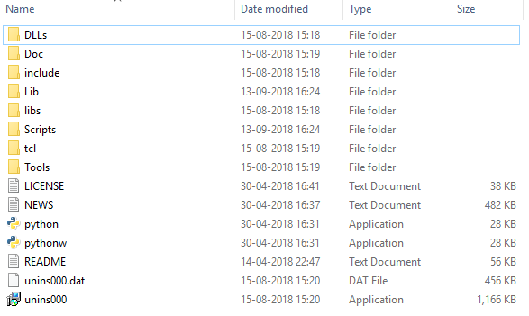 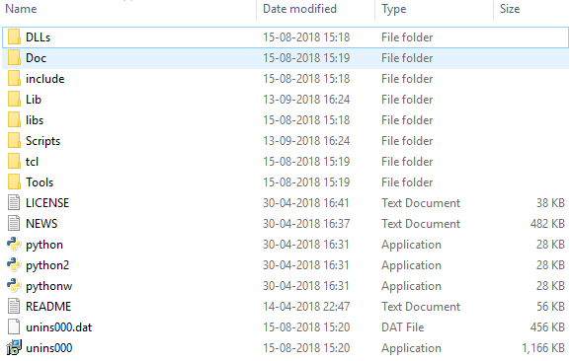

Python 3:

